# Temperature Prediction Using ANN with Fuzzy Logic Based on Weather Conditions

## Introduction

This experiment is trying to figure the temperature as a function of 4 parameters (winds, rains, humidity, and pressure). To do this, artificial neural network is used to figure the best function. In order to get the most accurate answers, we used fuzzy logic to evaluate the prediction instead the real values. We could later to get the real values out of that fuzzy data.

Artificial intelligence (AI) is a term, in its broadest sense, means the ability of a machine or artifact to perform functions similar to those that characterize human thought. The term Artificial Intelligence (AI) has been applied to computer systems and programs that can perform tasks which are more complex than straight forward programming, although still far from the realm of actual thought. AI consists of many branches such as, Expert Systems (ESs), Artificial Neural Networks (ANNs), Genetic Algorithms (Gas) and Fuzzy Logic (FL) and various Hybrid Systems (HSs), which are combinations of two or more of the branches mentioned previously (Medske, 1996)

"Fuzzy logic and artificial neural networks are important in the intelligent control of complex system" (Neural Fuzzy Inference System-Based Weather Prediction, p. 2). They are ,the fuzzy logic and ANNS, used together to solve problems based on ordered classes to predict some fuzzy percentage, or to be more accurate, a decimal value between 0-1 that will reveal the binominal prediction.

"Traditionally, ANNs use crisp weather variable as its inputs to predict crisp weather conditions, and in this paper, we use fuzzy weather variables as its inputs and predict the fuzzy weather condition instead. Our neural fuzzy inference system-based weather prediction model (NFIS-WPM) could infer a new reasonable fuzzy variable output according to the fuzzy variable inputs by using the algorithm we proposed in this paper and then we use this approach in weather forecasting. In addition, NFIS-WPM is based on another technique that combines ANNs and fuzzy logic. This technique is different from the previous three techniques since it embeds neural network into fuzzy logic engine with fuzzy input and fuzzy output values. In other words, the first approach and the new approach operate in opposite ways. Besides, this new technique is specifically designed for fuzzy inference problems and the others have different goals." (Hu, Xue, Xiakua, Zhang, & Lu, 2014, p. 2).

## Data Used in the Model

The data used are weather daily details of Holly Makkah collected by Holly Makkah weather station from 2008 to 2018. These details contain dates, temperature, humidity, rains, winds, and pressure.

## Requirement

This experiment uses the following:

### Python scripting language 3.6

Python is an interpreted, high-level, general-purpose programming language. Created by Guido van Rossum and first released in 1991, Python has a design philosophy that emphasizes code readability, notably using significant whitespace. It provides constructs that enable clear programming on both small and large scales. (Guttag, 2016). Python is widely used in data processing and AI application for its wide variance libraries.

### TensorFlow Library

Based on their official website: "TensorFlow is an open source software library for high performance numerical computation. Its flexible architecture allows easy deployment of computation across a variety of platforms (CPUs, GPUs, TPUs), and from desktops to clusters of servers to mobile and edge devices. Originally developed by researchers and engineers from the Google Brain team within Google’s AI organization, it comes with strong support for machine learning and deep learning and the flexible numerical computation core is used across many other scientific domains" (TensorFlow, n.d.)

### Numpy Library

NumPy is the fundamental package for scientific computing with Python. It contains a powerful N-dimensional array object, sophisticated (broadcasting) functions, tools for integrating C/C++ and Fortran code, and useful linear algebra, Fourier transform, and random number capabilities

Besides its obvious scientific uses, NumPy can also be used as an efficient multi-dimensional container of generic data. Arbitrary data-types can be defined. This allows NumPy to seamlessly and speedily integrate with a wide variety of databases. (NumPy, n.d.)

### Keras Library

Keras is a high-level neural networks API, written in Python and capable of running on top of TensorFlow, CNTK, or Theano. It was developed with a focus on enabling fast experimentation. Being able to go from idea to result with the least possible delay is key to doing good research. (Keras, n.d.).

### Anaconda

Anaconda Enterprise is an AI/ML enablement platform that empowers organizations to develop, govern, and automate AI/ML and data science from laptop through training to production. It lets organizations scale from individual data scientists to collaborative teams of thousands, and to go from a single server to thousands of nodes for model training and deployment (ANACONDA, n.d.).

### Jupeter Notebook

Notebook documents (or “notebooks”, all lower case) are documents produced by the Jupyter Notebook App, which contain both computer code (e.g. python) and rich text elements (paragraph, equations, figures, links, etc…). Notebook documents are both human-readable documents containing the analysis description and the results (figures, tables, etc..) as well as executable documents which can be run to perform data analysis (Jupyter Notebook, n.d.).

## Procedures

### Descriptive data

In this experiment, our goal is to achieve the highest possible accuracy for temperature prediction using for possible parameters: (winds, rains, humidity, and pressure). The data we have contains the minimum and maximum temperature. But, we really need is the average temperature. The same thing applies to the parameters. For pressure, we have both sea pressure and station pressure. So, we approved their average.

After having the averages, the charts show that there were some inconsistency in the date. This would lead to unpredictable results. In order to resolve this, we made some refine to the data by re-valuating the value into an average of it with the values before and after it. This refine has lessen the variance in the temperature and humidity, and made some sensible non-zero rainfall vector. And in last, it made some curves appear in the wind chart.

Charts before refine:

These charts, in comparison to these refined charts:

It is clearly visible that the variance in the refined data is less than the original data. Yet the original they both have the same average and range.

Considering outliers, pressure is the only set that contains outliers. The firs quartile value is about 990. The third quartile is about 997. Therefore, we have a range of about 7. In the light of that, the limits are about 980 – 1005. Still, we have values like 1008 and 899. All values more than 1005 are considered as 1005, and all values less than 980 are considered as 980.

### Fuzzyfier

As fuzzy logic "is an approach to computing based on degrees of truth" (Rouse, n.d.), we need to convert the data from their value into adjectives and a value that will measure how these cases belong to these adjectives.

In order to do that, a fuzzyfier is created. Many implementations for fuzzyfiers are commended (Aguilar-González, 2014), but as we are to convert the real degree of the temperature into fuzzy value in range of 0-1, the best way was to distribute the values accordingly.

In order to avoid values higher than one (in case of outliers), we use minimum function too. The full function is:

$fuzzyValue\left(refined(x)\right)=\frac{(x-\min\left(refined\left(x\right)\right)}{range(\max\left(refined\left(x\right)\right),\min\left(refined\left(x\right)\right)}$

### Processing

Processing is done using Jupyter Notebook IDE. The attached code contain the whole process.

As an example, data from year 2008-2016 considered to be training set. 2017-2018 where the testing set.

After many trials, it was clear that the highest accuracy is obtained after 19 epochs. It was clear that after that over-fit reduces the accuracy. In average, The accuracy obtained by 19 epochs is 81% and the final accuracy of the 19th is 87%.

### Defuzzyfier

The results of the neural network prediction is fuzzy values. Observing the result, we could find that the "relu" activation worked on making the values in sin-shaped function in range of (0-2). The first mission that the defussyfier should accomplish is to reweight the prediction. After many calculations, the function to correct the values is:

$$b\left(x\right)=0.7*\sin^{-1}{*}{\sqrt{\frac{sin⁡({\frac{πx}{6}-\frac{π}{2})+1}}{2}}}^{0.6}$$

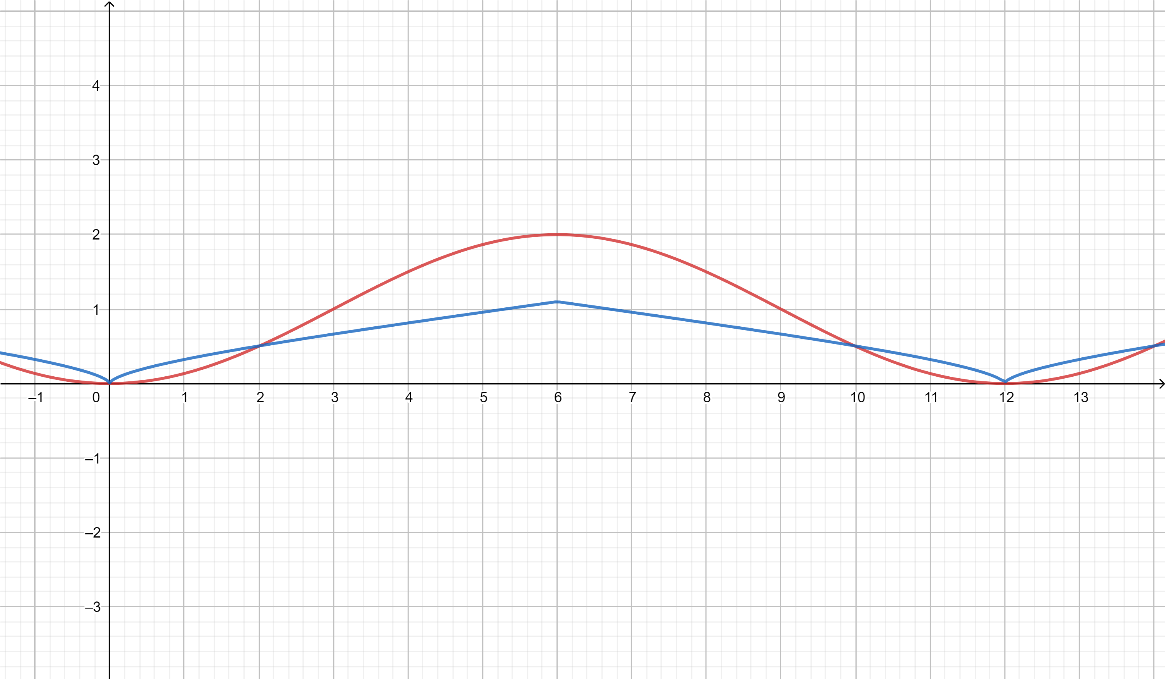

The red curve reveals the interval. The blue vector approximates the corrected values.

After that, the defuzzier function should evaluate the value and reform the temperature. The function to do that:

$$Temp\left(FuzzyX\right)=FuzzyX* range(\max\left(refined\left(x\right)\right).\min\left(refined\left(x\right)\right)+\min\left(refined\left(x\right)\right)$$

The results shows that the predictions are in average of range ±1 from the correct temperature, with about 16% accurate answers, and about 1.5% of maximum variance ±5

## References

Aguilar-González, A. &.-P.-D.-L.-R. (2014). Efﬁcient Design and Implementation of a Multivariate Takagi-Sugeno FuzzyController on an FPGA. *International Conference on Mechatronics.* Cuernavaca, México: Electronics and Automotive Engineering (ICMEAE 2014).

ANACONDA. (n.d.). *What is Anaconda*. Retrieved 1 20, 2019, from ANACONDA: https://www.anaconda.com/what-is-anaconda/

Guttag, J. (2016). *Introduction to Computation and Programming Using Python: With Application to Understanding Data.* MIT Press.

Hu, J., Xue, S., Xiakua, Z., Zhang, S., & Lu, W. (2014). Neural Fuzzy Inference System-Based Weather Prediction. *Atmosphere*, 788-805.

*Jupyter Notebook*. (n.d.). Retrieved 2 25, 2019, from Read The Docs: https://jupyter-notebook-beginner-guide.readthedocs.io/en/latest/what_is_jupyter.html

Keras. (n.d.). *Keras Home Page*. Retrieved 1 20, 2019, from Keras: https://keras.io/

Medske, L. R. (1996). Microcomputer applications of hybrid intelligent systems. *Journal of Network and Computer Applications, 19*, 213-234.

NumPy. (n.d.). *NumPy Home Page*. Retrieved 1 20, 2019, from NumPy: http://www.numpy.org/

Rouse, M. (n.d.). *fuzzy logic*. Retrieved 2 25, 2019, from EnterpriseAI: https://searchenterpriseai.techtarget.com/definition/fuzzy-logic

Spyder. (n.d.). *Spyder Home Page*. Retrieved 1 20, 2019, from Spyder: https://www.spyder-ide.org/

TensorFlow. (n.d.). *TensorFlow Home Page*. Retrieved 1 20, 2019, from TensorFlow: https://www.tensorflow.org/